An algebraic data type definition achieves several things simultaneously: it introduces a new type into scope, it gives an enumeration of the legal values of the new type and it defines both constructors for the values and it defines patterns for decomposing values. This is a lot for a single statement to do!
For example, we can define a type that denotes a point in a two-dimensional space:
<$Scr_Ps::0>type point ::= cart(float,float).
<!$Scr_Ps::0>This kind of statement is called a type definition statement and is legal in the same places that a function definition is legal.
The new type that is named by this statement is point; so, a variable may have point type, we can pass point values in functions and so on.
The constructor cart allows us to have expression that allow ‘new’ point structures to be made:
<$Scr_Ps::0>cart(3.4,2.1)
<!$Scr_Ps::0>cart is also the name of a pattern operator that we can use to take apart point values. For example, the euclid function computes the Euclidian distance associated with a point:
<$Scr_Ps::0>euclid:(point)=>float.
euclid(cart(X,Y)) => sqrt(X*X+Y*Y).
<!$Scr_Ps::0>Of course, this particular point type is based on the assumption that point values are represented in a cartesian coordinate system. One of the more powerful aspects of algebraic data types is that it is easy to introduce multiple alternate forms of data. For example, we might want to support two forms of point: in cartesian coordinates and in polar coordinates. We can do this by introducing another case in the type definition statement:
<$Scr_Ps::0>point ::= cart(float,float)
| polar(float,float).
<!$Scr_Ps::0>Of course, our euclid function also needs updating with the new case:
<$Scr_Ps::0>euclid:(point)=>float.
euclid(cart(X,Y)) => sqrt(X*X+Y*Y).
euclid(polar(R,T)) => R.
<$Scr_Cs::2><!$Scr_Ps::0>cart<!$Scr_Cs::2> and <$Scr_Cs::2>polar<!$Scr_Cs::2> are called constructor functions. The term constructor refers to the common programming concept of constructing data structures. They are called functions because, logically, they are functions.
For example, we might give a type to <$Scr_Cs::2>polar<!$Scr_Cs::2>:
<$Scr_Ps::0>polar : (float,float)=>point
<!$Scr_Ps::0>In fact, constructor functions are one-to-one functions. Variously known as free functions (in logic), bijections (in Math), one-to-one functions are guaranteed to have an inverse. This is the logical property that makes constructor functions useful for representing data.
Of course, we are talking of a logical property of constructor functions. Internally, when implementing functional languages like Star, the values returned by constructor functions are represented using data laid out in memory — just like any other programming language.
Star actually employs a special type for constructor functions; so the correct type of polar is given by:
<$Scr_Ps::0>polar : (float,float)<=>point
<!$Scr_Ps::0>The double arrow representing the fact that constructor functions are bijections.
In addition to constructor functions, an algebraic type definition can introduce two other forms of data: enumerated symbols and record functions. Enumerated symbols are quite useful in representing symbolic alternatives. The classic example of an enumerated type is <$Scr_Cs::2>daysOfWeek<!$Scr_Cs::2>:
<$Scr_Ps::0>daysOfWeek ::= monday
| tuesday
| wednesday
| thursday
| friday
| saturday
| sunday.
<!$Scr_Ps::0>Another example is the standard <$Scr_Cs::2>boolean<!$Scr_Cs::2> type which is defined:
<$Scr_Ps::0>boolean ::= true | false.
<!$Scr_Ps::0>Unlike enumerated symbols in some languages, there is no numeric value associated with an enumeration symbol: an enumerated symbol ‘stands for’ itself only. The reason for this will become clear in our next type definition which mixes enumerated symbols with constructor functions:
<$Scr_Ps::0>sTree ::= sEmpty | sNode(sTree,string,sTree)
<!$Scr_Ps::0>In addition to mixing the enumerated symbol (sEmpty) with the <$Scr_Cs::2>sNode<!$Scr_Cs::2> constructor, this type is recursive: in fact, this is a classic binary tree type where the labels of the non-empty nodes are strings. (We shall see shortly how to generalize this).
Whenever you have a recursive type, its definition must always include one or more cases that are not recursive and which can form the base case(s). In that sense, an enumerated symbol like sEmpty plays a similar role in Star has some of the same character as null does in other languages; except that sEmpty is only associated with the sTree type.
We can use sTree to construct binary trees of string value; for example:
<$Scr_Ps::0>sNode(sNode(sEmpty,"alpha",sEmpty),
"beta",
sNode(sEmpty,"gamma",sEmpty))
<!$Scr_Ps::0>denotes the tree in:
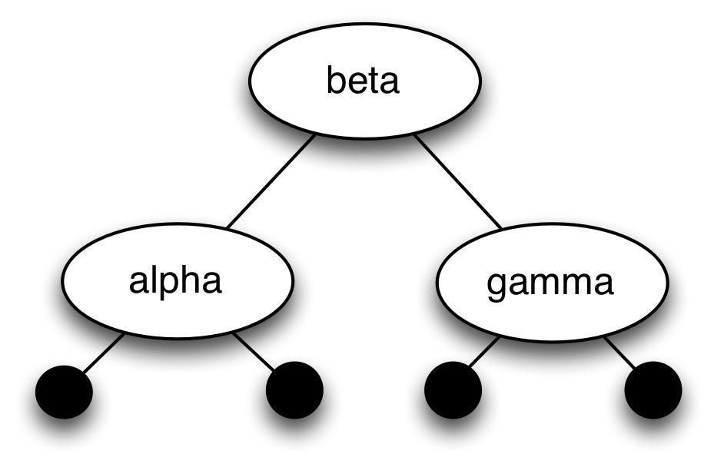
<$Scr_Ps::1>A Binary string Tree
<!$Scr_Ps::1>One of the hallmarks of languages like Star is that every value has a legal syntax: it is possible to construct an expression that denotes a literal value of any type.
Just as we can define sTree values, so we can also define functions over sTrees. For example, the check function returns true if a given tree contains a particular search term:
<$Scr_Ps::0>check:(sTree,string) => boolean.
check(sEmpty,_) => false.
check(sNode(L,Lb,R),S) => Lb=S || check(L,S) || check(R,S)
<!$Scr_Ps::0>Here we see several new aspects of Star syntax:
- An empty pattern — marked by _ — matches anything. It is called the anonymous pattern and is used whenever we don’t care about the actual content of the data.
- The <$Scr_Cs::2>||<!$Scr_Cs::2> disjunction is a short-circuit disjunction; much like <$Scr_Cs::2>||<!$Scr_Cs::2> in languages like Java. Similarly, conjunction (<$Scr_Cs::2>&&<!$Scr_Cs::2>) is also short-circuiting.
- Functions can be recursive. Star permits mutual recursion just as easily: there is no special requirement to order function definitions in a program.
We can use sTest to check for the occurrence of particular strings:
<$Scr_Ps::0>T : sTree.
T = sNode(sNode(sEmpty,"alpha",sEmpty),
"beta",
sNode(sEmpty,"gamma",sEmpty)).
show check(T,"alpha"). -- results in true
show check(T,"delta"). -- results in false<!$Scr_Ps::0>

